

**Project: BookStore**

**GROUP MEMBERS:**

1. 22K-4173 Ibrahim Abdullah
2. 22K-4544 Rohit Kumar
3. 22K-4625 Sayal Baig

**Section:** BCS-3G

**Teacher:** Basit Jasani

**1. Introduction:**

This project provides a basic skeleton behind the functioning of an online bookstore using various data structures. The project's primary goal is to get the user, both customer and admin, to interact with data stored in appropriate data structures and perform relevant actions with efficiency of speed and storage.

**2. Methodology:**

The project uses C++ programming language and a console based interface for allowing user to interact as user and as admin.

Algorithms/Data Structures/Methods used:

* Binary Search Tree for efficient searching of books
* AVL Tree for storing books
* Stack for purchasing books
* Graph for displaying friend preferences based on social activity
* Hash Tables for storing username and user password, and admin name and admin password by virtue of hashing function
* Linked Lists for storing chapter previews of books.
* Queue for level order traversals of tree

**3. System Architecture:**

The system architecture comprises three main components: the user interface, the application logic, and the data storage. These components interact seamlessly to provide users with a robust and responsive metro navigation experience.

**4. Features:**

The Online BookStore covers the following features:

* Addition, deletion, searching, and updating of books.
* Sorting books according to different criteria such as sales and genre.
* An efficient login authentication system using hash functions.
* Displaying best-selling books by maintaining heap data structure.
* Allowing user to purchase books.

Suggest books to users based on their preference and social activity.

**5. User Interface:**

The user interface is designed with simplicity and functionality in mind. Users can interact with the app through a console based interface, making it accessible for a wide range of users.

**6. Working of Project:**

The program initially asks you choose whether to login as user or as admin.

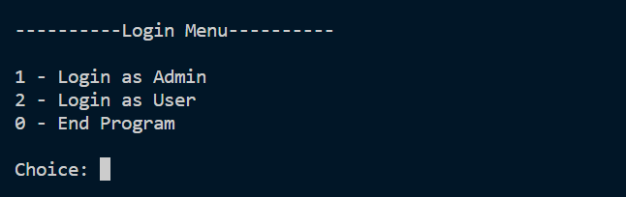

**Admin Features:**

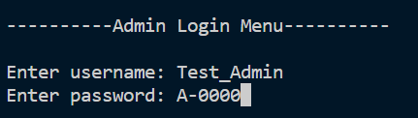

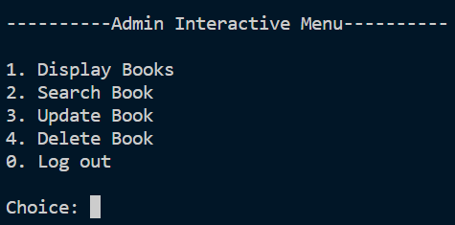

**User Features:**

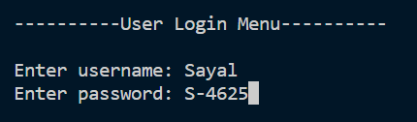

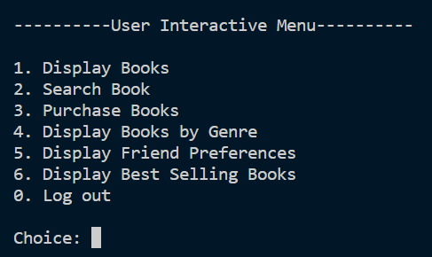

***Admin Features in use:***

*Display Books:  
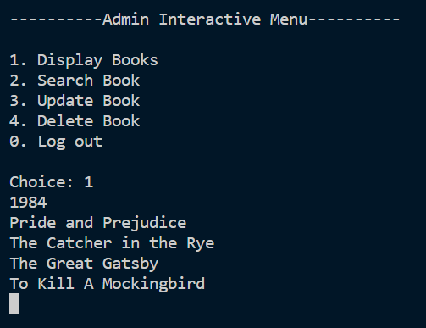*

*Search Books:  
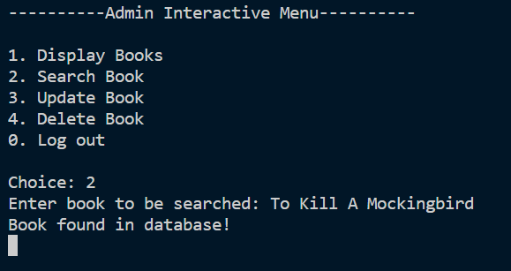*

*Update Books:  
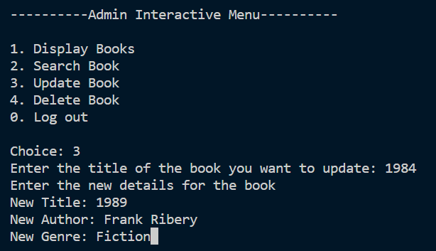  
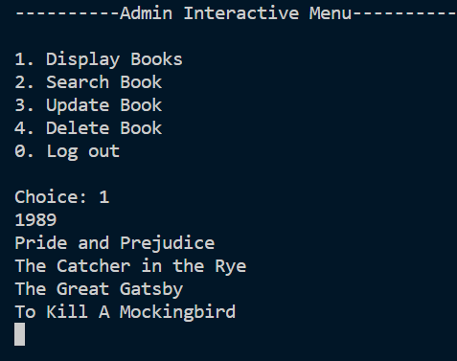*

*Delete Books:  
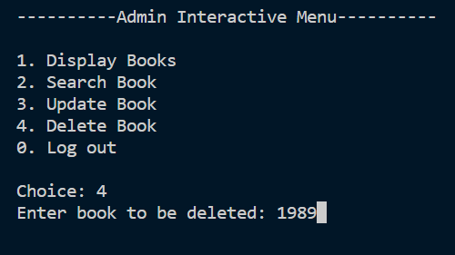* 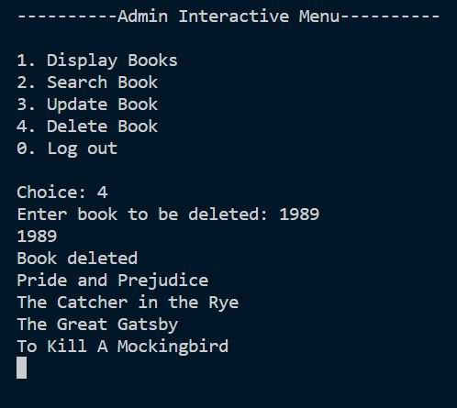

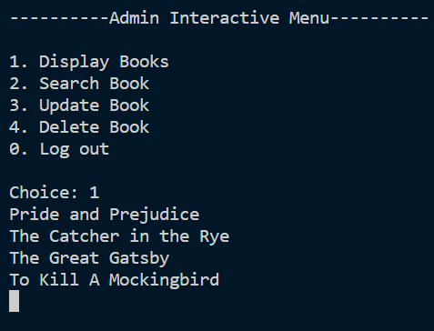

***User Features in use:***

*Display Books:*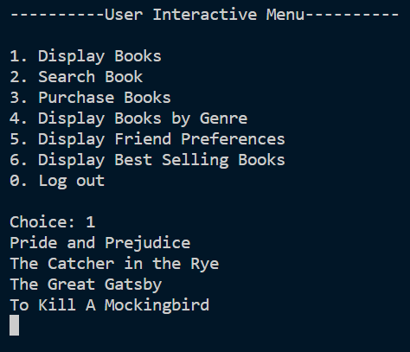

*Search Books:  
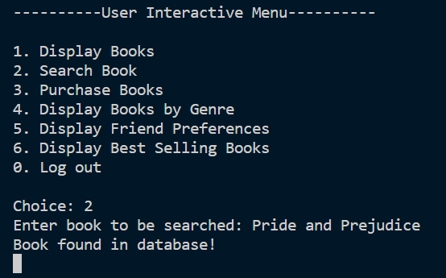*

*Purchase Books:  
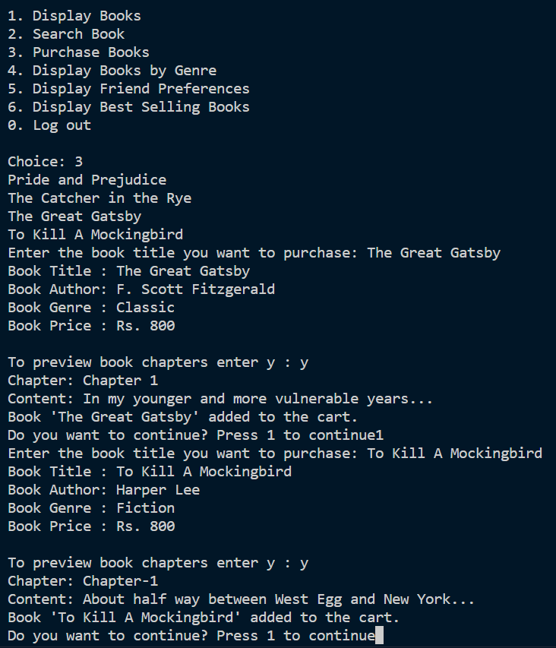*

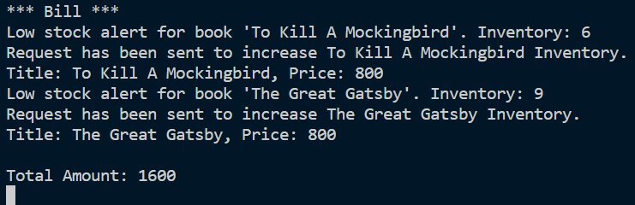

*Display Books by Genre:  
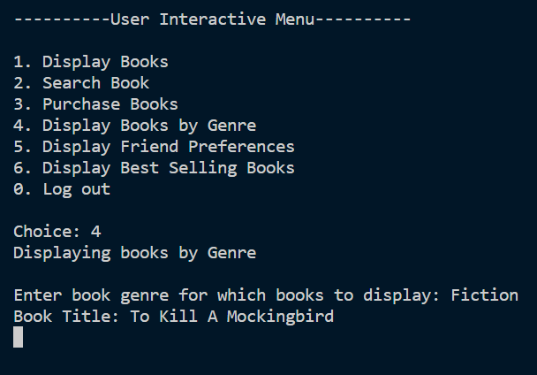*

*Display Friend Preference:  
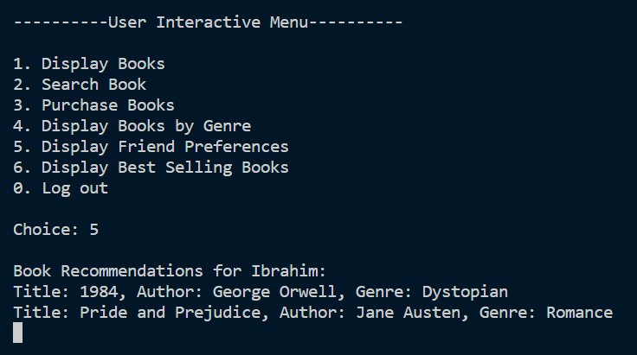*

*Display Best Selling Books:  
